; revised ; date of current version 17 May, 2023.

**Structural Characteristics and Ordered Clustering of Energy Embodied in International Trade**

**R. Baldwin**∗

1Department of Computer Science & Engineering, University of Nevada, Reno, NV 89557 USA

**ABSTRACT** International trade can be understood as a complex network consisting of edges signifying the flow of a commodity between exporting and importing country nodes. To enable the flow of goods from one economy to another, materials must be extracted, refined, and transported, requiring additional material and energy input to the system of trade. Global trade networks can be transformed to represent not only the flow of commodities between countries, but the flow of embedded (or embodied) materials and energy required to facilitate the movement of goods.

In this project, the flow of energy derived from fossil fuels and alternative energy required to meet the final demand of international economies are mapped as complex networks to elucidate structural characteristics, key actors, and community formation in the transfer of embodied energy. Data for the flow of environmental footprints between sectors and countries is obtained from the Eora26 database. Due to computational constraints, embodied energy flows are aggregated to the regional level, ignoring interactions between sectors. The topological structure of the network is characterized according to degree distribution, average path length, and average edge weight. The roles of individual economies in the network is assessed by degree, betweenness, and closeness centrality metrics. Finally, community formation is evaluated using an ordered, hierarchical Stochastic Block Model to understand the direction of energy transfer between and among communities through global trade.

1. **INTRODUCTION**

**I**

NTERNATIONAL trade enables a robust system for the production and distribution of goods and services. Within

a globalized market, economies can gain access to resources, commodities, and productive capabilities that may otherwise be unobtainable. This also means that final consumption of a commodity is often far removed from production and its associated impacts. A nation that consumes an imported final product is not directly impacted by the land use required to extract its raw materials or the pollution produced by foreign manufacturing. In a sense, international trade involves the transfer of both commodities and their social or environ- mental impacts. Such impacts are said to be “embodied in” trade.

Analyzing the impacts embodied in the goods consumed by an economy gives a way to understand what activities are required to meet the needs of an economy, and where those activities take place. International trade has developed in such a way that social and environmental impacts are dis- placed away from the point of consumption. As worldwide economic growth continues, and trade becomes increasingly globalized, it is important to understand the extent, location, and mechanisms of impacts embodied in international trade. Multi-Regional Input-Output Analysis (MRIO) has previ- ously described international embodied trade flows. In partic-

ular, consumption-based footprint indicators have established clear relationships between economic growth and the propa- gation of environmental indicators along international supply chains. However, these studies are often focused on the net requirements of a given commodity, rather than the structure of the activities required to meet those requirements. In other words, MRIO may describe the greenhouse gas emissions embodied in a nation’s economy, but it fails to capture the movement of embodied emissions from extraction to final consumption.

To better understand the structure of embodied trade flows, MRIO can be supplemented with a complex network model of international trade. Global bilateral trade can be modeled as a directed, weighted network consisting of nodes representing trade participants (nations, sectors, etc.) and links from exporting participants to importing participants. Complex network analysis provides a means of studying global and community structure of the trade network, as well as the roles and characteristics of key actors.

Modeling international trade as a complex network allows economies to be understood within the context of both direct and indirect effects. Direct effects can be easily understood as the exchange of energy or materials between two economies. For example, when a commodity is exported, there is a simultaneous flow of embodied quantities such

This work is licensed under a Creative Commons Attribution 4.0 License. For more information, see https://creativecommons.org/licenses/by/4.0/

VOLUME , 1

as energy use or greenhouse gas emissions. Indirect effects of trade occur when the activities of external actors impact direct effects between economies. For example, preferential trade with a particular partner may reduce the flow of embodied quantities through other actors.

Analyzing key actors in the international trade network can provide a deeper understanding of the mechanism through which embodied quantities are transferred to con- suming economies. A node’s in-strength measures the sum of weights of edges leading into the node. A high in-strength for embodied energy flow would indicate that maintaining a nation’s consumption requires significant energy input from other actors in the network. Other centrality measures may be used to identify important sources of embodied quantities, countries that act as mediators for the transfer of those quantities between producing and consuming countries, and how influential net importing and exporting countries are in the flow of embodied quantities throughout the network.

Complex network analysis can reveal useful information regarding the global and community structure of interna- tional trade systems. Previous studies have shown that the embodied energy flow network exhibits small-world and scale-free properties. The scale-free nature of international trade indicates that economies serve unique roles in the network and demonstrate preferential attachment when form- ing trade relations. Community analysis can be used to understand how economic and environmental impacts are concentrated throughout the network, and which actors most significantly influence one another’s actions.

Previous studies regarding the environmental impacts of international trade have mostly consisted of a combination of environmentally-extended MRIO and complex network analysis. MRIO can generate each nation’s footprint for an embodied quantity of interest. Complex network analysis then highlights central actors and overall network struc- ture. The typical approach is to correlate network roles and structure to environmental outcomes. Few studies have utilized complex network analysis to explore the mechanisms through which countries with high environmental footprints displace these impacts. This project will attempt to analyze the topology of the international trade network to identify trends of impact deplacement and dependency.

1. **BACKGROUND AND RELATED WORK**

Foundational research concerning the social and environmen- tal impact of international trade primarily utilized MRIO to measure national footprints of interest. Hertwich & Peters (2009) were among the first to measure carbon footprint at a national level from a single, trade-linked model of the global economy. A primary motivation for their research was to develop a new perspective on the drivers of global greenhouse gas emissions. The authors presented a method- ology that provided a consistent treatment of economies in the scope of the study at the expense of lower data quality and resolution. Pre-existing input-output tables were sup-

plemented with additional emissions data that agreed better with national statistics. Their results showed that indirect effects embodied in the supply chain were more significant than direct effects observed at the point of consumption. Wiedmann et al. (2015) developed the material footprint (MF) metric and performed a similar analysis to assess the resource extraction necessary to sustain the economies of different nations. Their methodology utilized an input-output database with a much higher resolution than Hertwich & Peters. The results also clearly indicated the displacement of environmental impacts along the supply chain. In particular, the authors found that two-fifths of global raw materials were solely extracted and used to support international trade activities. Furthermore, economic growth is associated with a higher material footprint, resulting in net-exporting countries experiencing the bulk of the environmental consequences. These studies indicate that the structure of international trade affects the intensity and location of environmental and social impacts of economic activity. However, their analysis is limited to highlighting differences in economic and environmental indicators between nations. Both studies lack a substantial discussion of how structural or temporal phenomena relate to their findings.

Investigating the structure of world trade requires a com- plex network approach. Aller et al. (2015) studied world trade as a complex network and assessed its environmental impacts. In addition to direct effects of trade, the authors proposed two indirect effects: reduction in access to environ- mentally friendly goods and market power, both of which can be described by the tools of network theory. Unfortunately, these effects were not rigorously defined within the context of network theory. Instead, the Eigenvector, Betweenness, Out-closeness, In-closeness, and Closeness were measured for each country and used as a general descriptor for indirect effects. The authors measured correlations between *CO*2 emissions and each centrality measure, along with volume of exports. Emissions were positively correlated with trade volume and closeness centrality, but other centrality mea- sures provided less useful information. While this research provides a promising initial examination of the relationship between network properties and trade impacts, it lacks any discussion of the overall network structure. Furthermore, it attempts to correlate centrality metrics with final emissions data, rather than constructing a network of embodied flows for analysis.

Several studies in the past decade have employed a hybrid approach which combines MRIO with complex network analysis. The typical approach is to use MRIO to calculate embodied flows and analyze the properties of the resultant network. Chen et al. (2018) utlized this method to examine energy flows embodied in international trade. This paper provides one of the most extensive descriptions of the network properties of an embodied flow network. The au- thors found that the embodied energy flow network (EEFN) exhibits small-world and scale-free nature. The characteristic

path length of the EEFN was 2.23, and over half of the neighbors of a specific economy tended to have connections with one another. The authors explain that the scale-free nature of the EEFN indicates that actors in the network exercise preferential growth and have varied impacts on the impacts of the network. The authors also divided the network into four regional communities, though the community- detection methodology is unclear. Community analysis helps to demonstrate which countries have the strongest impacts on each other. Finally, key economies were identified according to centrality measures. The authors provide a more extensive analysis of the significance of highly central economies and suggest that energy-related policies specifically target influ- ential countries to propagate globally beneficial outcomes.

Few studies have tried to explain the mechanisms guiding the displacement of environmental outcomes in the global trade network. Ren et al. (2022) utilized network control theory to assess control and dependence relationships in international trade. Under this model, a nation’s control and dependence with relation to other countries is associated with its export and import of embodied energy, respectively. The network control analysis found that developed countries tend to rely on developing countries by importing goods and services that consume energy in the exporting country. The authors also construct various control and dependency motifs to determine the properties and prevalence of various control relationships in the international trade network.

This research will build on previous methods of studying embodied flows in the international trade network. By an- alyzing network topology and the properties of key actors in the network, this project will attempt to explain the relationship between network structure and environmental impacts embodied in international trade.

1. **METHODOLOGY**

**T**

O analyze the structure and dynamics of the exchange of environmental impacts embodied in international trade, global embodied energy derived from fossil fuels and alternative energy sources is mapped as two complex networksk. Input-output data can be used to construct a network of embodied fossil-fuel energy flows at the sector or economy level. First, a network of 26 sectors across 189 countries (N = 4914, E = 24147396) can be constructed, but computational constraints prevented any substantial analysis of the network. Therefore, structural characteristics, central- ity measures, and hierarchical clustering was evaluated on an aggregated network of embodied energy flows between

countries (N = 189, E = 35532).

The structure of the embodied energy flows through the global economy will be analyzed in several ways. Analysis of network topology gives insight to the scale and structure of impact exchanges between economies. The role of individual economies or sectors can be assessed by calculating var- ious centrality measures. Hierarchical clustering illustrates key dependence relationships in the embodied energy flow

network, and allows for the categorization and ranking of economies as upstream (net energy consumption exporter), downstream (net importer), or lateral.

1. ***Data Source***

The network is constructed from the Eora26 database. The standard Eora database is presented as a balanced global Multi-Regional Input Output table documenting transfers between 15,909 sectors across 190 countries, along with data describing 2720 environmental indicators. Eora has previously been applied to Environmentally Extended Input- Output Analysis, as well as Complex Network Analysis of the world trade network. This study uses a simplified version called Eora26, which is freely available for academic use and less computationally burdensome. The simplified tables contain transfer data for 26 aggregated sectors across 189 countries.

The Eora26 database is equipped with matrices summariz- ing the net impacts of each sector in each economy, as well as the net impacts by final consumers. Although the IO tables do not describe the transfer of impacts between economies or sectors, this information can be obtained through a series of standard transformations to the IO data, as described in the following subsection.

1. ***Network Construction***

Parsing and processing of the Eora26 database was achieved using the Pymrio library for Python. The nodes of the network represent economies at either the sectoral or regional level, while the edges represent the total energy requirement per target node required to meet the final demand of each source node. The edges can be thought of as the energy requirements off-shored from the source economy to the target economy. For a given economy, the total industry ouput *x* is calculated as

*x* = (*I − A*)*−*1*y* = *Ly* (1)

Where, *A* is the direct requirement matrix, *y* is a final de- mand vector, and *L* is the Leontief inverse matrix (*I A*)*−*1. Multipliers reflecting the total energy requirement factors for one unit of input are obtained by

*−*

*M* = *F diag*(*x*)*−*1*L* (2)

Where F is the factor of production matrix. For a given final demand vector, *y*, the footprint required to meet final demand is given by

*Dcba* = *My* (3)

Calculating the consumption-based accounts for the en- ergy footprint in each region required to meet the energy demand of all other regions yields the embodied-energy flow network. Aggregating at the regional level gives the regional embodied energy transfer network.

At a later point in the analysis, it was discovered that some edge weights were negative, which was unexpected according to the methodology described here. It may be the case that errors existed in the code, or that a different methodology should be followed for the construction of the network. Future work on this topic would begin by addressing network construction from the IO tables. For the purposes of this project, modifications were made to the edge weight data to allow for the necessary calculations. Based on a series of trial calculations, it was observed that removal of these nodes outright significantly affected the structure of the underlying network. Therefore, all negative edge weights were mapped to their absolute values. Although this allowed for stable calculations, the source and significance of the negative edge weights could not be identified, so the information lost or affected by this mapping is unknown.

1. ***Network Structure***

The structure of impact networks has previously been studied for several indicators. However, an account of the topological characteristics of impact networks provides useful insights in the context of this report and will be included in the analysis of the network. The primary structural metrics of interest are the Degree Distribution and Density. All topological calculations were performed in the Python library graph-tool. The degree distribution of a network describes the fre- quency of each node degree. In the context of impact transfers in the global economy, Degree Distribution can be thought of as a measure of the extent to which environmental burdens are offshored to producing countries. For example, a scale-free weighted out-degree distribution would indicate that a few countries have a tendency to export a large portion of the impacts embodied in their final demand to other countries in the network. A scale-free weighted in-degree distribution might indicate that a small number of countries tend to import the bulk of global trade environmental trade

impacts.

The network density describes how well connected a net- work is, and can be calculated from the following equation.

*D* = (4)

*M*

*N* (*N −* 1)

Where *M* is the number of edges and *N* is the number of nodes. The network Density can be thought of as a measure of how connected the impact transfer network is. A high density indicates that a substantial number of impact exchanges exist in global trade. This would have significant implications for global emissions reduction policy. In the extreme case of zero transferred impacts between countries, emissions generated by an economy could be assumed to be the responsibility of that economy alone. However, as the density of the impact network increases, trade relations become increasingly important in determining strategies to reduce environmental impacts of trade.

1. ***Hierarchical Partitions***

Hierarchical partitions was achieved using a nested stochastic block model (SBM). SBM is a generative method that is ca- pable of identifying arbitrary preferences between groups of nodes via Bayesian inference. Given a graph *G*, the optimal partition *bi* , is the one which maximizes the probability of generating *G* given a prior partitioning, *P* (*G bi*. Hierarchical ordering can be obtained by recursively applying the SBM algorithm to partitions of the graph, such that each layer partitions the previous one. A full account of the theoretical background and derivation of the nested SBM algorithm is given by Peixoto. The author has made the method available as part of the graph-tools package, which was used to obtain the hierarchical orderings.

*|*

*{ }*

The first layer of the nested SBM consists of all nodes and

edges in *G*. The first layer identifies communities according to similar weighted edges, and aggregates nodes into com- munities based on their rank in the embodied energy flow network. Top ranking nodes represent nations with a high total energy requirement, i.e. the nations in which energy production occurs to meet the demand of trade partners. Low ranking nodes have a low total energy requirement, which can be the result of off-shoring their energy requirement or an intrinsically low footprint. An intermediate rank indicates countries with primarly lateral footprint exchanges.

1. ***Economy Role Analysis***

As is the case with network structure metrics, the computa- tion of centrality measures to analyze the role of individual economies in global impact exchange networks has been studied extensively in the literature. Various centrality mea- surements can be interpreted as indicators of an economy’s participation in impact exchange through trade.

Node strength is the weighted sum of edges in or out of a node. In the context of impact transfers, this is equivalent to the total volume of an impact imported or exported by a country.

Closeness centrality is a measure of the average distance to or from a node. In the context of impact transfer networks, the out centrality of an economy can be thought of as its abil- ity to dissipate the environmental impacts of its final demand throughout the network. Alternatively, the in centrality of an economy indicates its vulnerability to becoming a sink for environmental impacts.

The betweenness of a node is a measure of the number of shortest paths that travel through it. In the context of impact transfer networks, this can be thought of as the extent to which a node acts as an intermediary for impact exchange. A node with high betweenness may be a critical component in the overall impact transfer process from primarily exporting countries to primarily importing countries.

Although network topology and node centrality measures have been analyzed in previous studies, there has been little effort to compare or correlate network properties between different indicators. In general, previous studies have focused

on one indicator (e.g. CO2 emissions or energy use). A potential opportunity for study would be to generate metrics for several impact transfer networks. Comparison between these metrics may reveal that structural properties of transfer networks vary by indicator.

1. **Results and Discussion**
2. ***Structural Characteristics***

The degree distribution was calculated and plotted on a log- log plot to assess the structure of the network. The results for the out-degree distributions are shown in Figure 1.

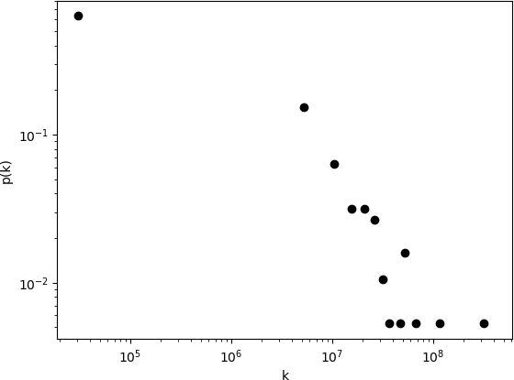

* 1. Fossil Fuel Network

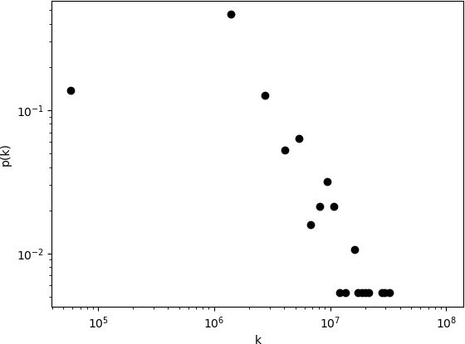

* 1. Alternative Fuel Network

FIGURE 1: Degree distribution of each network indicating scale-free properties

Both networks appear to be linear in the log-log space of *p*(*k*) vs *k*, indicating that the degree distribution follows a power law. The power law degree distribution is a defining characteristic of scale-free networks. The observation that these networks are scale free indicate that a small number of economies export a significant quantity of the energy demand associated with their final demand to other countries.

Consequently, most economies export a significantly smaller portion of their energy footprint through trade compared to the top economies. The in-degree distributions showed similar trends, indicating that the same conclusions can be drawn about net-energy-demand importing countries.

The fossil fuel network exhibited an average weighted path length and average edge weight of 164.5 and 61,683, respectively, while the same values for the non-fossil fuel network were 197.2 and 24,895. The fact that the average path length is significantly lower than the average edge weight in both networks reaffirms the observations given by the degree distribution. The average path length can be thought of as the average energy footprint of each country that it transfers to all other countries, while the average embodied energy exchange among all pairs of countries. The discrepancy between these two values indicates that most of the embodied energy transferred through international trade occurs through relatively rare, but significant exchanges between country pairs. This observation implies that the source of apparent energy footprints observed in countries with high energy demand is concentrated and occurs through relatively few and intensive transfers.

1. ***Centrality Measures***

The degree centralities of the fossil fuel network are shown in Figure 2(a) and 2(b). A high out-degree centrality in this context indicates that a large portion of an economy’s energy footprint is realized in external economies, while a a high in- degree indicates that a large portion of a country’s footprint is derived from the final demand of its trading partners.

The trends for both in- and out-degree centralties show a heavy dominance of the top economies. A similar trend can be observed in the non-fossil fuel network. The out- degree trends of the top-ten economies in the non-fossil- fuel network indicate a more uniform reliance of these countries to meet the energy requirements of their final demand without fossil fuels. The fact that the non-fossil fuel requirement to final demand is less varied is likely related to the availability of alternative energy technology globally. If alternative energy is relatively scarce, it is more likely that a similar portion of the energy requirement met by alternative energy of a given set of countries will be similar.

The Betweenness centrality of the most central countries in each network are shown in Figure 2(c) and 2(g). The betweenness centrality of a node is the number of shortest paths passing through it. In the context of global embodied energy trade, a high betweenness centrality indicates that a country is a hub of low embodied energy transfer through global trade. A series of trades between two nations that pass through an economy with high betweenness centrality will involve a smaller embodied energy transfer compared to a series of trades that does not. The betweenness centrality for the fossil fuel and alternative energy networks shows that the same groups of countries serve as low energy transfer hubs in each network

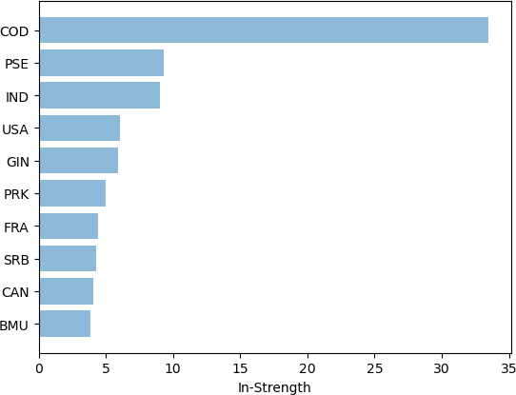 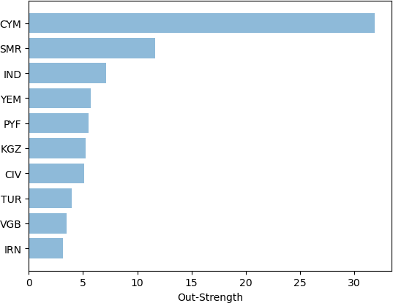 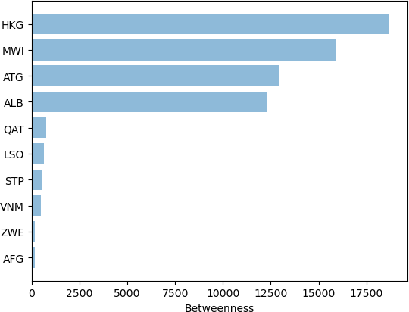 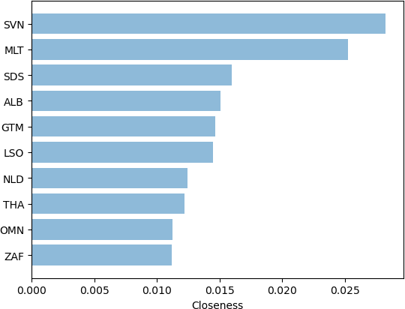

(a) (b) (c) (d)

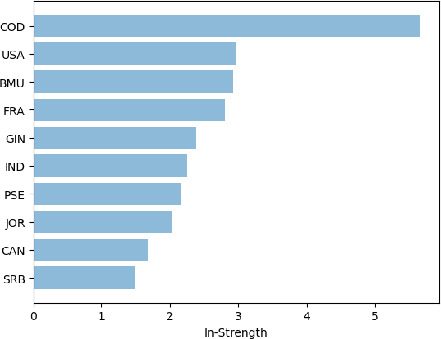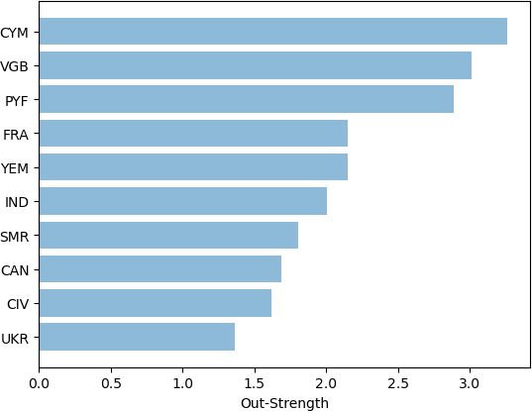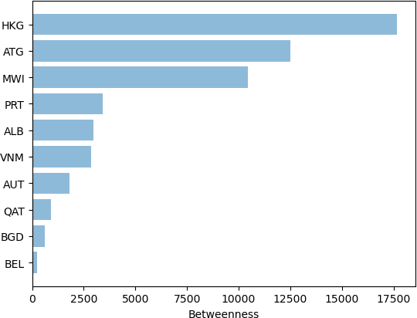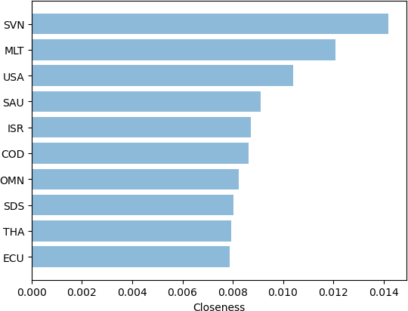

(e) (f) (g) (h)

FIGURE 2: Centrality measures for the fossil fuel network (a-d) and the alternative fuel network (e-h)

The closeness centrality of a node represents the number of shortest paths between the node and all other nodes. In the context of global embodied energy trade, closeness centrality indicates the ability of a node to meet its final demand without a substantial transfer of its energy requirement to other economies in the network.

1) Ordered Hierarchical Clustering

The ordered hierarchical clustering of a weighted, directed network provides a means of ranking communities according to their upstream, downstream, and lateral interactions with other communities. High rank (upstream) economies tend to transfer the energy requirement in their final demand to economies downstream. Countries in the lowest rank include Venezuela, Iraq, and New Zealand, while countries in the highest rank include Djibouti, Benin, and Namibia. The United States, Japan, and China are all located in the third rank. The basic hierarchical and block structures for each network are shown in the Figure 3.

The structure of the Hierarchical Block Network (shown in blue with square nodes representing blocks) is bipartite indicating that two main communities with similar edge patterns exist in the network. One interpretation may be that the divide lies between countries that primarily transfer the energy requirements of their final demand to other coun- tries, and the other primarily incurs the associated footprint. However, the hierarchical grouping may be the result of regional or preferential interactions among economies in each group. Further research could elucidate the significance of this clustering by analyzing qualitative economic features such as regional characteristics, economic indicators, and total energy footprint of the economies in each block.

The structure of the hierarchical and ordered block models for the fossil fuel and alternative energy network is very similar. However, top rank countries in the odered block

model for the alternative energy network are significantly different than the fossil fuel network. Whereas the fossil fuel network contained almost no EU countries, the top rank of the alternative energy network is almost exclusively EU countries. Conversely, the bottom rank contains only Guyana and Somalia and the membership of many of the intermediate ranks is relatively similar to the fossil fuel network. Again, further analysis should be performed to correlate this ordering to properties of economies in shared communities.

1. **Conclusion**

In this report, the structural characteristics and national roles of actors in the global embodied energy trade network were evaluated. Both networks were found to be scale-free, indicating that embodied energy transfer happens through relatively few, highly intensive exchanges between country pairs. Communities in the international embodied energy trade network were identified using a Stochastic Block Model. The SBM revealed that economies in the embodied trade network are separated into two distinctive blocks according to similarities in edge characteristics. Further research should be conducted to elucidate the source and nature of these similarities to better understand the structure and mechanics of embodied energy transfer between and among communities.

Some uncertainty persists in the conclusions drawn in this report due to an error in network construction. Future work on this topic would begin with an alternative construction method to ensure that all embodied flows between economies are positive and reflective of actual exchanges occuring in the network. Furthermore, the use of centrality metrics that rely on weighted shortest paths inflates the centrality measures of economies with relatively minor trade interactions with other countries in the network. With the current network construc- tion, a short path length between two nodes could indicate

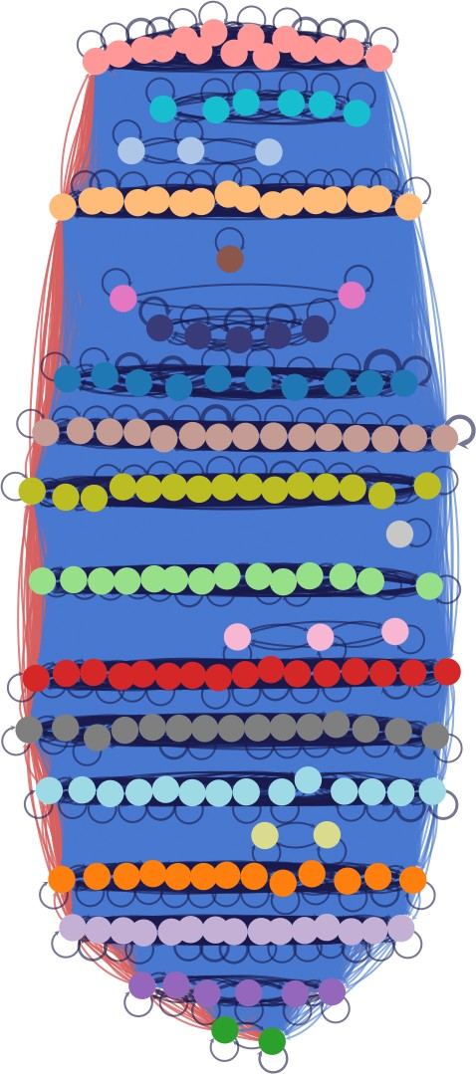  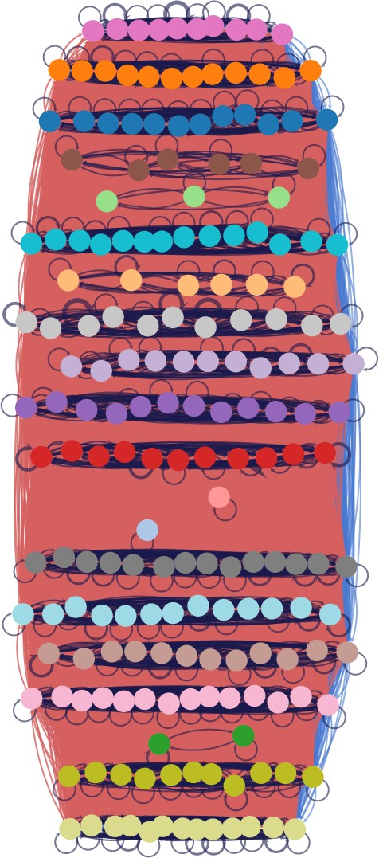 

(a) (b) (c) (d)

FIGURE 3: Hierarchical structure and radial block partition graph of the fossil fuel network (a-b) and the alternative energy network (c-d)

low embodied energy exchange through a series of trade interactions or that the two economies have relatively few trade interactions. Future work should begin by partitioning the network either by regional aggregation or SBM, followed by an analysis of the embodied energy trade characteristics within the identified partitions.

Complex network analysis provides significant insight into environmental footprints embodied in international trade, with important implications for international sustainability policy. Ordered hierarchical block modelling elucidates key communities and indicates the general direction of embodied energy flow through the global trade network. These insights can be used to better understand the source and impacts of environmental footprints such as energy requirement, emis- sions, biodiversity loss, and labor impacts such as wages, employment and migration.

**REFERENCES**

1. T. P. Peixoto, “Ordered community detection in directed networks,”

*Physical Review E*, vol. 106, no. 2, 2022.

1. T. Wiedmann and M. Lenzen, “Environmental and social footprints of international trade,” *Nature Geoscience*, vol. 11, no. 5, pp. 314–321, 2018.
2. M. Lenzen, D. Moran, K. Kanemoto, and A. Geschke, “Building Eora: a Global Multi-Region Input-Output Database At High Country and Sector Resolution,” *Economic Systems Research*, vol. 25, no. 1, pp. 20– 49, 2013.
3. C. Aller, L. Ductor, and M. J. Herrerias, “The world trade network and the environment,” *Energy Economics*, vol. 52, pp. 55–68, 2015.
4. K. Stadler, “pymrio Documentation,” p. 410, 2018.
5. Y. L. Li, B. Chen, and G. Q. Chen, “Carbon network embodied in international trade: Global structural evolution and its policy implica- tions,” *Energy Policy*, vol. 139, no. February, 2020.
6. B. Chen, J. S. Li, X. F. Wu, M. Y. Han, L. Zeng, Z. Li, and

G. Q. Chen, “Global energy flows embodied in international trade: A combination of environmentally extended input–output analysis and complex network analysis,” *Applied Energy*, vol. 210, no. October 2017, pp. 98–107, 2018.

1. B. Ren, H. Li, J. Shi, N. Ma, and Y. Qi, “Detecting the control and dependence relationships within the global embodied energy trade network,” *Energy*, vol. 238, p. 121678, 2022.
2. N. Wunderling, J. Kro¨nke, V. Wohlfarth, J. Kohler, J. Heitzig, A. Staal,

S. Willner, R. Winkelmann, and J. F. Donges, “Modelling nonlinear dynamics of interacting tipping elements on complex networks: the PyCascades package,” *European Physical Journal: Special Topics*, vol. 230, no. 14-15, pp. 3163–3176, 2021.

1. M. Jiang, H. An, X. Gao, S. Liu, and X. Xi, “Factors driving global carbon emissions: A complex network perspective,” *Resources, Conservation and Recycling*, vol. 146, no. April, pp. 431–440, 2019.
2. J. Shi, H. Li, J. Guan, X. Sun, Q. Guan, and X. Liu, “Evolutionary features of global embodied energy flow between sectors: A complex network approach,” *Energy*, vol. 140, pp. 395–405, 2017.
3. J. Neumann, M. Petranikova, M. Meeus, J. D. Gamarra, R. Younesi,

M. Winter, and S. Nowak, “Recycling of Lithium-Ion Batter- ies—Current State of the Art, Circular Economy, and Next Generation Recycling,” *Advanced Energy Materials*, vol. 12, no. 17, 2022.

1. T. O. Wiedmann, H. Schandl, M. Lenzen, D. Moran, S. Suh, J. West, and K. Kanemoto, “The material footprint of nations,” *Proceedings of the National Academy of Sciences of the United States of America*, vol. 112, no. 20, pp. 6271–6276, 2015.
2. E. G. Hertwich and G. P. Peters, “Carbon footprint of nations: A global, trade-linked analysis,” *Environmental Science and Technology*, vol. 43, no. 16, pp. 6414–6420, 2009.
3. M. Jiang, X. Gao, Q. Guan, X. Hao, and F. An, “The structural roles of sectors and their contributions to global carbon emissions: A complex network perspective,” *Journal of Cleaner Production*, vol. 208, pp. 426–435, 2019.
4. “The eora global supply chain database.” Accessed: 2023-05-17.